Comedia Musica Players
1409 14th Ave N.
Fort Dodge, IA 50501

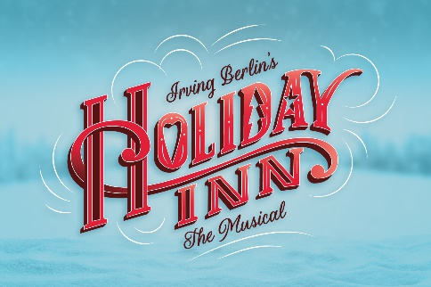
The Comedia Musica Players Present:
“HOLIDAY INN”
Historic Phillips Auditorium

November 7th, 8th & 9th, 2024
7:00pm nightly, and a 2:00pm show on 11/9

Visit us at WWW.COMEDIAMUSICA.COM or www.facebook.com/comediamusicaplayers!
Irving Berlin's Holiday Inn tells the story of Jim, who leaves the bright lights of show business behind to settle down on his farmhouse in Connecticut... but life just isn't the same without a bit of song and dance. Jim's luck takes a spectacular turn when he meets Linda, a spirited schoolteacher with talent to spare. Together they turn the farmhouse into a fabulous inn with dazzling performances to celebrate each holiday, from Thanksgiving to the Fourth of July. But when Jim's best friend Ted tries to lure Linda to Hollywood to be his new dance partner, will Jim be able to salvage his latest chance at love?
Based on the classic film, this joyous musical features thrilling dance numbers, laugh-out-loud comedy and a parade of hit Irving Berlin songs, including "Blue Skies," "Easter Parade," "Steppin' Out With My Baby," "Heat Wave," "White Christmas," "Be Careful, It's My Heart," "Cheek to Cheek," "Shaking the Blues Away" and many more!
"This year-round romance is sure to delight audiences!”
“Holiday Inn" is presented through special arrangement with Concord Theatricals and all authorized performance materials are supplied by: Concord Theatricals, 250 W. 57th Street, 6th floor, New York, NY 10107-0102,
Phone: 866-979-0447

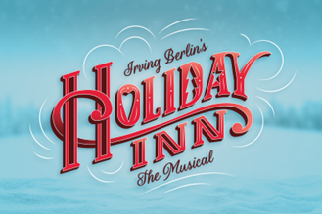
The Comedia Musica Players
“HOLIDAY INN”
November 7-9, 2024
Historic Phillips Auditorium

Dear Friend of Musical Theatre: We’re so excited to perform for you in our fall production of "Holiday Inn”!
We hope you will enjoy the show this year, and we look forward to seeing you there!

The Comedia Musica Players is a non-profit organization. Your tax-deductible sponsorship will help assure the continuation of quality musical theater in your community. Your support is vital and very much appreciated.

Mail orders will be filled in the order they are received. Tickets may be purchased in person at HyVee beginning Wednesday, October 9th or online at www.comediamusica.com. TICKETS ARE GENERAL ADMISSION.

-------------------------------------------------------------------------------------------------------------------------------------------------

SPONSORSHIP LEVELS:
Please check the sponsorship level desired.
____ EXECUTIVE PRODUCER (Full page ad + 10 tickets) - $500.00+
____ PRODUCER (Half page ad + 8 free tickets) - $350.00
____ DIRECTOR (Quarter page ad + 6 free tickets) - $200.00
____ LEADING PLAYER (Business Card size ad + 4 free tickets) - $150.00
____ SUPPORTING CAST (Program Listing + 2 free tickets) - $75.00
____ STAGE CREW (Program Listing only) – Any amount, up to $75.00
All sponsors will be listed prominently in our program. Ads are seen by over 1000 people in a span of 3 days. If you would like to have an ad featured in our program, email ad copy to info@comediamusica.com.

NAME OF BUSINESS / ORGANIZATION / INDIVIDUAL:
____________________________________________________________________

ADDRESS: ___________________________________________________________
PHONE: ___________________________ EMAIL: ____________________________________________

Sponsors receiving tickets have their choice of performance. A board member will contact you for performance choice by November 1st. If you have already decided on a performance choice, please circle it here: Th Fr Sat-2pm Sat-7pm

D.A.R.T. SHUTTLE BUS SERVICE PROVIDED IN THE PARKING LOTS BEFORE / AFTER PERFORMANCES.

TOTAL AMOUNT DUE = $ ____________________

Mail form to Comedia Musica Players at 1409 14th Ave N., Fort Dodge, IA 50501 OR scan/email form and send to info@comediamusica.com.
PAYMENT OPTIONS:
____ Mail check payable to “Comedia Musica Players” to 1409 14th Ave. N, Fort Dodge, IA 50501
____ Pay via Paypal to info@comediamusica.com
____ Credit Card #________________________________ Exp: ______________ CVV: ____________

Please call AMY PORTER at 515-408-3152 with any questions or concerns.

